Jacob Hopkins  
11/3/2020  
Final Project Proposal

**Research Question**Integration of clustering algorithms, like k means, for tsp with permutation encoded genetic algorithms of said sub clusters.

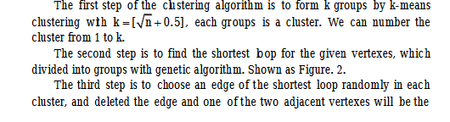

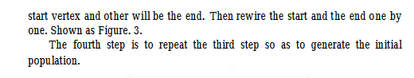

With the integration of master slave architecture upon GPUs for solving cluster tsp GA’s, in which each slave can run in a thread.

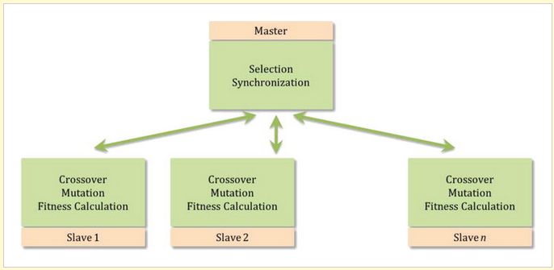

The literature talks about the advantages of using permutation encoding for GA of tsp so that is what I am going to do. I am unsure if the previous work is using permutations. I assume so, but I have yet to find it in my reading. Or at least not in this entire combination.

Each group would be given a population of random permutations with the start and end constraints of the closest cities between two adjacent clusters.

Ultimately to compare hardware utilization to that of problem search space utilization by giving a comparison of conventional permutation encoded tsp GA with and without gpu to that of k means tsp ga with and without gpu.

**Comparative Research**

An improved genetic algorithm based on k-means clustering for solving traveling salesman problem: <https://www.researchgate.net/publication/309149000_An_improved_genetic_algorithm_based_on_k-means_clustering_for_solving_traveling_salesman_problem>

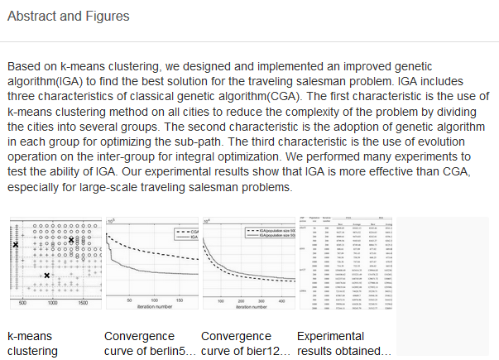

Solution to travelling salesman problem by clusters and a modified multi-restart iterated local search metaheuristic: <https://www.ncbi.nlm.nih.gov/pmc/articles/PMC6104944/>

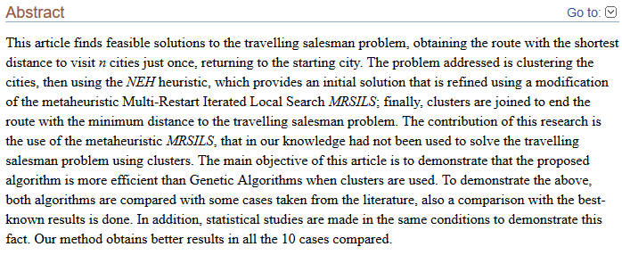

Parallel Genetic Algorithms with GPU Computing: <https://www.intechopen.com/books/industry-4-0-impact-on-intelligent-logistics-and-manufacturing/parallel-genetic-algorithms-with-gpu-computing>

